# Farmers Bidding System

# Long Description:

India needs to properly assess and resolve the issue of losses in food grains during selling them.

• Storage is the major cause of post-harvest losses for all kinds of food in India, which is estimated at around 15% by the Food Corporation of India. 20-30% of fruits and vegetables are estimated to be wasted due to lack /delay in consumption/selling of produce.

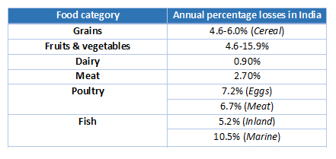

**Source:** *National Academy of Agricultural Sciences*

• A key issue is the availability of surplus food grains with FCI, well above its buffer capacity. For instance, its rice stocks were at 21 MT in January this year compared to a buffer requirement of 7 MT. This happens as local farmers do not have idea on estimated demand. So overproduction can be prevented as producers will get to know the estimated demand of the crops.

• This technology can help reduce wastage occurring due to not getting the consumer on time and keep farm produce less volatile to market fluctuations.

A bidding system is to enable farmers to get the best value of their products from multiple co-operatives and for Co-operatives to get the best quality at the best bid for buyers. This will encourage speedy consumption of the farm produce and thus will avoid food wastage.

**Overview of the System**

Based on the market demands, the co-operative will be able to float tenders for the required products with the desired quantity and quality. Co-operatives can finalize a base price using AI/ML algorithms which would use current demands, previous trends etc.

All the farmers registered in the system for that product will be notified through SMS. They can respond back with the quality, quantity and an offer price.

On the day of tender opening, the co-operatives can review and approve the bids. Farmers will be informed about the results via SMS.

# Solution roadmap:

Sequence diagram is ready. We will learn IBM cloud and will try to develop the actual solution.

# Link to GitHub code repository:

<https://github.com/MeeruChandra/TRUISTRangers>

# Link to a three-minute Demo Video

<https://youtu.be/Ql9QgI2YQMc>

# List of IBM Cloud Services or IBM Systems used in the solution.

1. IBM Push Notification
2. IBM SMS Gateway
3. IBM Cloudant Database
4. IBM Cloud Paks for running AI/ML engine
5. NODE RED APP
6. IBM Cloud functions
7. IBM Cloud database (RDBMS)

# Team leaders will need to provide information on up to four additional team members.

Rahul D Yadav ([radyadav@in.ibm.com](mailto:radyadav@in.ibm.com))

Manisha Kale [manikal1@in.ibm.com](mailto:manikal1@in.ibm.com))

Sushma Tiwary ([sushmtiw@in.ibm.com](mailto:sushmtiw@in.ibm.com))

Sayantan Banerjee ([Sayantan.Banerjee@ibm.com](mailto:Sayantan.Banerjee@ibm.com))

Meetu Chandra ([meecha97@in.ibm.com (Squad Leader)](mailto:meecha97@in.ibm.com%20(Squad%20Leader))